5th Grade Weekly Newsletter
Week of: April 13, 2020

Sherwood Archers: We hope that all is going well with your families. Please remember to follow the CDC guidelines. We will get through these trying times. These enrichment activities will help the scholars stay on track while school is closed. Thanks for all your support. #staysafe

Weekly Journal Prompt: Write a paragraph on how the COVID-19 has affected your life and your family’s life?

5th Grade Teachers | Office Hours
Ms. Davis 5-01:  Tuesday 8 a.m. – 10 a.m.  Thursday 9 a.m. – 11 a.m.  Phone: (901) 602-6014  Email: davismy@scsk12.org  https://www.classdojo.com/ | Ms. Payne 5-03:  Tuesday 11 a.m. – 1 p.m. & 3 p.m. – 5 p.m.  Thursday 11 a.m. – 1 p.m. & 3 p.m. – 5 p.m.  Phone: (662) 913-9133  Email: paynec@scsk12.org  https://www.classdojo.com/
Mr. Pumphrey 5-02:  Tuesday 11 a.m. – 1 p.m.  Thursday 12:30 p.m. - 2:30 p.m.  Phone: (901) 290-3796  Email: pumphreyk@scsk12.org  https://www.classdojo.com/ | Mrs. Bryant 5-04  Tuesday 11 a.m. – 1 p.m.  Thursday 12:30 p.m. - 2:30 p.m.  Phone: (901) 306-6813  Email: johnsones@scsk12.org  https://www.classdojo.com/
5th Grade | Monday
Math: (5.NBT.B.5) Fluently multiply multi-digit whole numbers  (up to three-digit by four-digit factors) using appropriate strategies and algorithms.  www.edugoodies.com  I-Ready 30-minute Lesson  Do Now: 32 X 34 = | ELA: (R.L.5.9) Compare and contrast settings and events  www.edugoodies.com  I-Ready 30-minute Lesson  Do Now: https://drive.google.com/file/d/1myB5x7AZwev_JlEWuMBbtlpXfkf8DNQy/view  Use the above link. Complete the Read Works article.
Social Studies: (s-w.co/TN5-2)  TN. Edition Studies Weekly  Great Plains, Great Pains?  Directions: Read Buffalo Soldiers Keep the Peace and Where the Buffalo Roam?  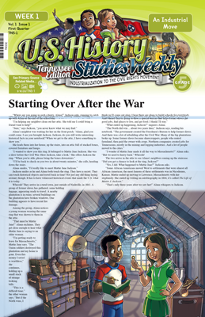  Highlight the link, right click, and click on open hyperlink. https://cdn.studiesweekly.com/WeeklyPDFs/TN5V20/2.pdf | Science: (s-w.co/S5P-2)  Science Studies Weekly  All About Matter  Directions: Read All About Matter  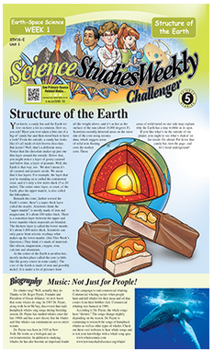  Highlight the link, right click, and click on open hyperlink. https://cdn.studiesweekly.com/WeeklyPDFs/S5V16/2.pdf
5th Grade | Tuesday
Math: (5.NBT.B.5) Fluently multiply multi-digit whole numbers  (up to three-digit by four-digit factors) using appropriate strategies and algorithms.  www.edugoodies.com  I-Ready 30-minute Lesson  Do Now: 234 x 15 = | ELA: (R.L.5.9) Compare and contrast settings and events  www.edugoodies.com  I-Ready 30-minute Lesson  Do Now: https://drive.google.com/file/d/1j939OYV52U-ipGjdp8lXHDhIziksiNy0/view  Use the above link. Read the article and answer the questions that follow.
Social Studies: (s-w.co/TN5-2)  TN. Edition Studies Weekly  Great Plains, Great Pains?  Directions: Read Westward Expansion  Highlight the link, right click, and click on open hyperlink.  https://cdn.studiesweekly.com/WeeklyPDFs/TN5V20/2.pdf | Science: (s-w.co/S5P-2)  Science Studies Weekly  All About Matter  Directions: Biography: Dr. Patricia Bath  Highlight the link, right click, and click on open hyperlink.  https://cdn.studiesweekly.com/WeeklyPDFs/S5V16/2.pdf
5th Grade | Wednesday
Math: (5.NBT.B.5) Fluently multiply multi-digit whole numbers  (up to three-digit by four-digit factors) using appropriate strategies and algorithms.  www.edugoodies.com  I-Ready 30-minute Lesson  Do Now: 432 x 265 = | ELA: (R.L.5.9) Compare and contrast settings and events  www.edugoodies.com  I-Ready 30-minute Lesson  Do Now: Write a 3 paragraph journal entry comparing and contrasting virtual school and school inside of a building.
Social Studies: (s-w.co/TN5-2)  TN. Edition Studies Weekly  Great Plains, Great Pains?  Directions: Read Chief Black Kettle: Powerful Peacemaker and The Pony Express  Highlight the link, right click, and click on open hyperlink.  https://cdn.studiesweekly.com/WeeklyPDFs/TN5V20/2.pdf | Science: (s-w.co/S5P-2)  Science Studies Weekly  All About Matter  Directions: Understanding Matter  Highlight the link, right click, and click on open hyperlink.  https://cdn.studiesweekly.com/WeeklyPDFs/S5V16/2.pdf
5th Grade | Thursday
Math: (5.NBT.B.5) Fluently multiply multi-digit whole numbers  (up to three-digit by four-digit factors) using appropriate strategies and algorithms.  www.edugoodies.com  I-Ready 30-minute Lesson  Do Now: 45 x 27 = | ELA: (R.L.5.9) Compare and contrast settings and events  www.edugoodies.com  I-Ready 30-minute Lesson  Do Now: Find two different types of literature in your house, and make a graphic organizer comparing and contrasting the points of view in each text.
Social Studies: (s-w.co/TN5-2)  TN. Edition Studies Weekly  Great Plains, Great Pains?  Directions: Complete the Activity Page: Western Trails  Highlight the link, right click, and click on open hyperlink.  https://cdn.studiesweekly.com/WeeklyPDFs/TN5V20/2.pdf | Science: (s-w.co/S5P-2)  Science Studies Weekly  All About Matter  Directions: High-Tech Ink! and Transfiguration: ‘Harry Potter’ series by J. K. Rowling  Highlight the link, right click, and click on open hyperlink.  https://cdn.studiesweekly.com/WeeklyPDFs/S5V16/2.pdf
5th Grade | Friday
Math: (5.NBT.B.5) Fluently multiply multi-digit whole numbers  (up to three-digit by four-digit factors) using appropriate strategies and algorithms.  www.edugoodies.com  I-Ready 30-minute Lesson  Do Now: 3456 x 22 = | ELA: (R.L.5.9) Compare and contrast settings and events  www.edugoodies.com  I-Ready 30-minute Lesson  Do Now: 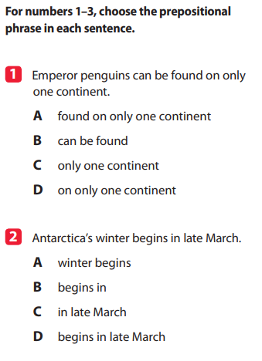
Social Studies: (s-w.co/TN5-2)  TN. Edition Studies Weekly  Great Plains, Great Pains?  Directions: Take the Assessment  Highlight the link, right click, and click on open hyperlink.  https://cdn.studiesweekly.com/WeeklyPDFs/TN5V20/2.pdf  Bonus: Cross word puzzle | Science: (s-w.co/S5P-2)  Science Studies Weekly  All About Matter  Directions: Take the Assessment  Highlight the link, right click, and click on open hyperlink.  https://cdn.studiesweekly.com/WeeklyPDFs/S5V16/2.pdf  Bonus: Cross word puzzle or Mini-Lab
Support | Classes
Art: | Computer:
Guidance: | Library: Read your favorite book to your family.
Music: | P.E.

